i) What is File Operation and File Permission in Linux Operating System?
File Operation :
All data in Linux is organized into files. All files are organized into directories. These directories are organized into a tree-like structure called the filesystem.
When we work with Linux or Unix, one way or another, we spend most of our time working with files. In the below section we will discuss how to create ,remove,copy and rename file in Linux.
In Linux, there are three basic types of files −
- Ordinary Files − An ordinary file is a file on the system that contains data, text, or program instructions. Here we look at working with ordinary files.
- Directories − Directories store both special and ordinary files. For users familiar with Windows or Mac OS, Linux /Unix directories are equivalent to folders.
- Special Files − Some special files provide access to hardware such as hard drives, CD-ROM drives, modems, and Ethernet adapters. Other special files are similar to aliases or shortcuts and enable us to access a single file using different names.
Basic File operation in Linux is given below :
Listing Files : To list the files and directories stored in the current directory, use the following command − $ ls
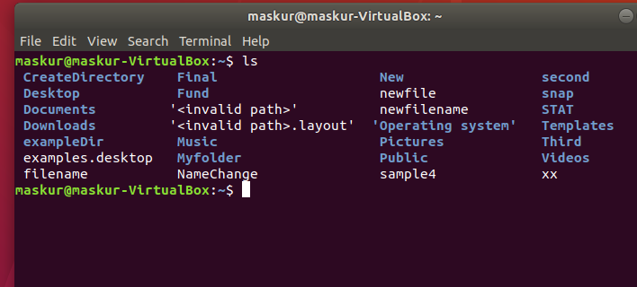
The command ls supports the -l option which would help us to get more information about the listed files -

$ ls -l
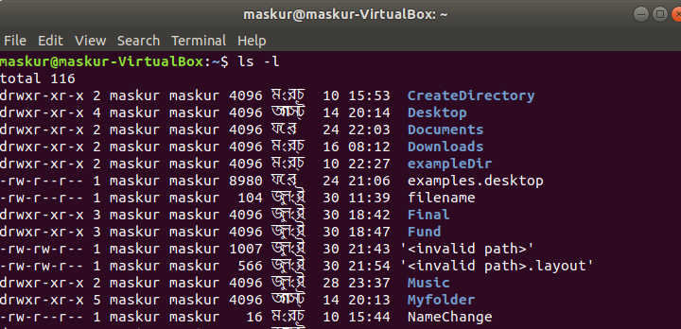
Here is the information about all the listed columns −
- First Column − Represents the file type and the permission given on the file. Below is the description of all type of files.
- Second Column − Represents the number of memory blocks taken by the file or directory.
- Third Column − Represents the owner of the file. This is the Linux user who created this file.
- Fourth Column − Represents the group of the owner. Every Linux user will have an associated group.
- Fifth Column − Represents the file size in bytes.
- Sixth Column − Represents the date and the time when this file was created or modified for the last time.
- Seventh Column − Represents the file or the directory name.
In the ls -l listing example, every file line begins with a d, -, or l. These characters indicate the type of the file that's

Symbol | Meaning
- | Regular file
d | Directory
l | Link
c | Special file
s | Socket
p | Named pipe
b | Block device

Metacharacters
Metacharacters have a special meaning in Linux. For example, * and ? are metacharacters. We use * to match 0 or more characters, a question mark (?) matches with a single character.
For Example −
$ls doc*.txt
Displays all the files, the names of which start with doc and end with .txt −
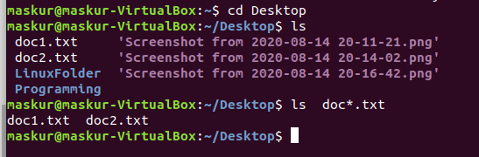
Here, * works as meta character which matches with any character. If we want to display all the files ending with just .png then we can use the following command −
$ls *.png
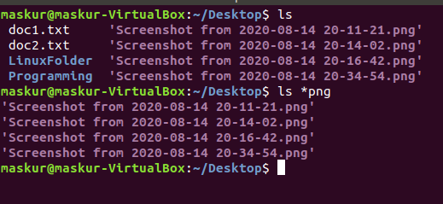

Hidden Files
An invisible file is one, the first character of which is the dot or the period character (.). Unix programs (including the shell) use most of these files to store configuration information.
Some common examples of the hidden files include the files −
- .profile − The Bourne shell ( sh) initialization script
- .kshrc − The Korn shell ( ksh) initialization script
- .cshrc − The C shell ( csh) initialization script
- .rhosts − The remote shell configuration file
To list the invisible files, specify the -a option to ls −
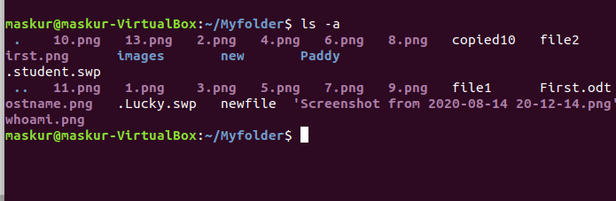
- Single dot (.) − This represents the current directory.
- Double dot (..) − This represents the parent directory

Creating Files
We can use the vi editor to create ordinary files on any Unix system. We simply need to give the following command −
$ vi filename
The above command will open a file with the given filename. Now, press the key i to come into the edit mode. Once we are in the edit mode, we can start writing our content in the file as in the following program −
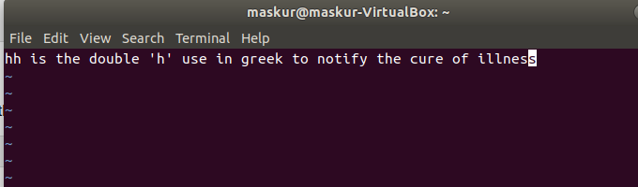

Once we are done with the program, follow these steps −
- Press the key esc to come out of the edit mode.
- Press two keys Shift + ZZ together to come out of the file completely.
We will now have a file created with filename in the current directory.

Display Content of a File
We can use the cat command to see the content of a file. Following is a simple example to see the content of the above created file .
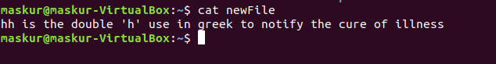

Counting Words in a File
We can use the wc command to get a count of the total number of lines, words, and characters contained in a file. Following is a simple example to see the information about the file created above −
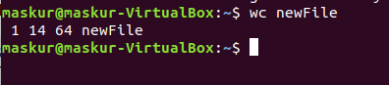

Here is the detail of all the four columns −
- First Column − Represents the total number of lines in the file.
- Second Column − Represents the total number of words in the file.
- Third Column − Represents the total number of bytes in the file. This is the actual size of the file.
- Fourth Column − Represents the file name.
We can give multiple files and get information about those files at a time. Following is simple syntax −
$ wc filename1 filename2 filename3
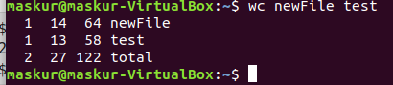

Copying Files
To make a copy of a file use the cp command. The basic syntax of the command is −
$ cp source_file destination_file
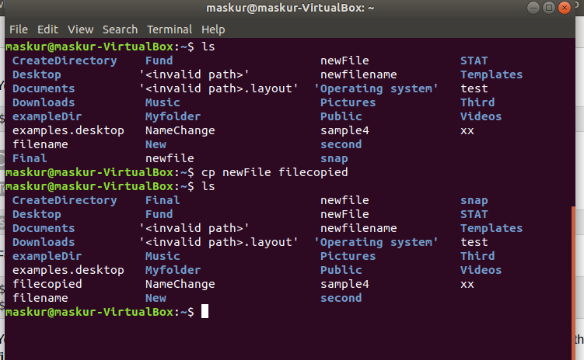

Renaming Files
To change the name of a file, use the mv command. Following is the basic syntax −
$ mv old_file new_file
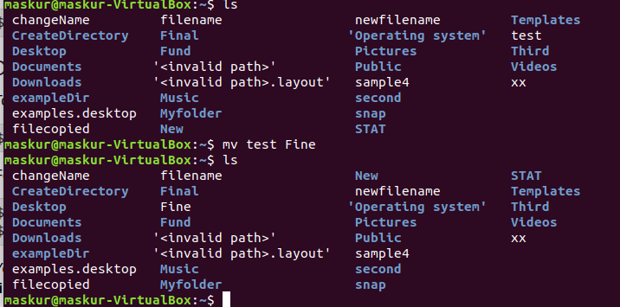
The following program will rename the existing file test to Fine.

Deleting Files
To delete an existing file, use the rm command. Following is the basic syntax −
$ rm filename
Here in the following command $ rm doc1 will remove the doc1 file.
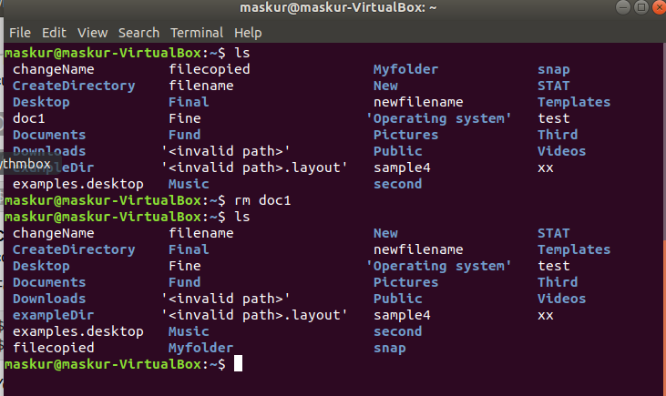
We can remove multiple files at a time with the command given below −
$ rm filename1 filename2 filename3
Here in the following command we use: $ rm filecopied test
which will remove filecopied and test
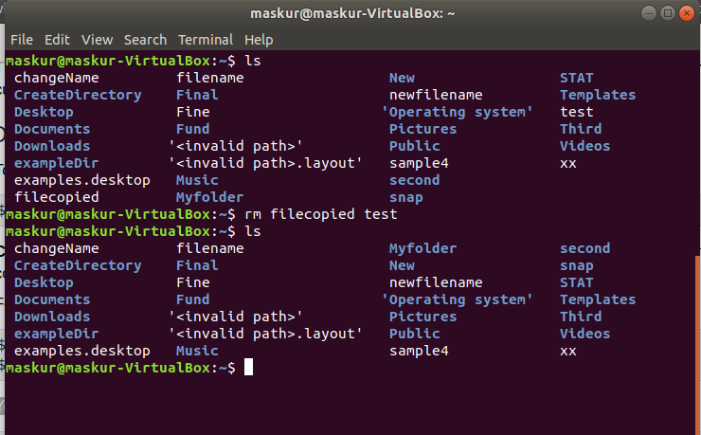

Linux is a clone of UNIX, the multi-user operating system which can be accessed by many users simultaneously. Linux can also be used in mainframes and servers without any modifications. But this raises security concerns as an unsolicited or malign user can corrupt, change or remove crucial data. For effective security, Linux divides authorization into 2 levels.
- Ownership
- Permission

Ownership of Linux files
Every file and directory on your Unix/Linux system is assigned 3 types of owner, given below.

User
A user is the owner of the file. By default, the person who created a file becomes its owner. Hence, a user is also sometimes called an owner.

Group
A user- group can contain multiple users. All users belonging to a group will have the same access permissions to the file. Suppose we have a project where a number of people require access to a file. Instead of manually assigning permissions to each user, we could add all users to a group, and assign group permission to file such that only this group members and no one else can read or modify the files.

Other
Any other user who has access to a file. This person has neither created the file, nor he belongs to a usergroup who could own the file. Practically, it means everybody else. Hence, when we set the permission for others, it is also referred as set permissions for the world.
Now, the big question arises how does Linux distinguish between these three user types so that a user 'A' cannot affect a file which contains some other user 'B's' vital information/data. It is like we do not want our colleague, who works on our Linux computer, to view our images. This is where Permissions set in, and they define user behavior.

Permissions
Every file and directory in your UNIX/Linux system has following 3 permissions defined for all the 3 owners discussed above.
- Read: This permission give us the authority to open and read a file. Read permission on a directory gives us the ability to lists its content.
- Write: The write permission gives us the authority to modify the contents of a file. The write permission on a directory gives us the authority to add, remove and rename files stored in the directory. Consider a scenario where we have to write permission on file but do not have write permission on the directory where the file is stored. we will be able to modify the file contents. But we will not be able to rename, move or remove the file from the directory.
- Execute: In Windows, an executable program usually has an extension ".exe" and which we can easily run. In Unix/Linux, we cannot run a program unless the execute permission is set. If the execute permission is not set, we might still be able to see/modify the program code(provided read & write permissions are set), but not run it.
Owners assigned Permission On Every On File and Directory.
The command ls -l is used to see all the information of file or directory.
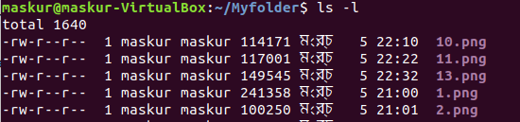
Here the first column is the file permission. Where ,
r for read permission , w for write permission , x for execute permission.

